Name:___________________________________ Date: ______________________
Homework

Directions: Each day of the week for homework, your child will choose ONE activity that is listed. Parents, please sign your initials each day on the work your child did. I will check their homework for completion each Friday!
Monday | Tuesday | Wednesday | Thursday | Friday
- Write four words that rhyme with ring. Illustrate each word. Select one from you list and write a sentence.  - Choose 5 beginning consonants from below and write a three letter word. (t,b,f,m,n, c,g,d,s,e,r,p,j,h,l,k,w,v) Example: top, cat, dog Sound out and illustrate each word.  - Say the following CVC (consonant vowel consonant) words to your child. Ask your child to verbally identify the beginning sound they hear. Extension activity: have your child also identify the middle and ending sounds.  cat, big, wig, dog, fun, run, bed, hop, log, win, van, pop, jug, gag  Practice sight words each night. Don’t forget to review old ones. | - Quantity Discrimination: List 2 numbers and have your child circle which one of the two is larger. Use numbers 1-20. Do 10 examples  For example:  2 7 8 3  - Call out a number 1-20 and have your child record the number and then write the correct number of tally marks to go with the number.  - See attached worksheet. Have your child place the correct number of dots in each ten frame.  Practice sight words each night. Don’t forget to review old ones. | - Read a fall book with someone in your family. Divide a paper into three sections. Label the sections beginning, middle and end. Draw a picture and write a sentence for each part.  - Draw a picture of a bat. Write 2 fact sentences about your picture.  - Use a magazine or newspaper to find 5 pictures that begin with Ww and Vv. Glue them to a piece of paper. Label the pictures.  Practice sight words each night. Don’t forget to review old ones. | - Circle sight words in a (newspaper, magazine, junk mail or internet resources such as sight word poems)  Answer the following questions.  I circled sight words in _______________.  I found these words:  _(word)_(how many times) ___times.  ______(how many times) ____times.  ______(how many times) ____times.  ______(how many times) ____times.  ______(how many times) ____times.  - Chose 5 sight words to write in rainbow colors  (rainbow writing is choosing 3 to 5 colors and tracing the whole word with each color)  - Choose 3 sight words and write a sentence for each one. Choose one of your sentences and illustrate.  - Type all 5 sight words on the computer. Type each word 5 times experimenting with different fonts. Print out page and glue or staple in your journal. all all all all all  Sight word List 10: she, do, how, their, if | All HOMEWORK  DUE  TODAY!  Have a Great Weekend!
I chose activity #______.  Parent initials:________ | I chose activity #______.  Parent initials:________ | I chose activity #______.  Parent initials:________ | I chose activity #______.  Parent initials:________
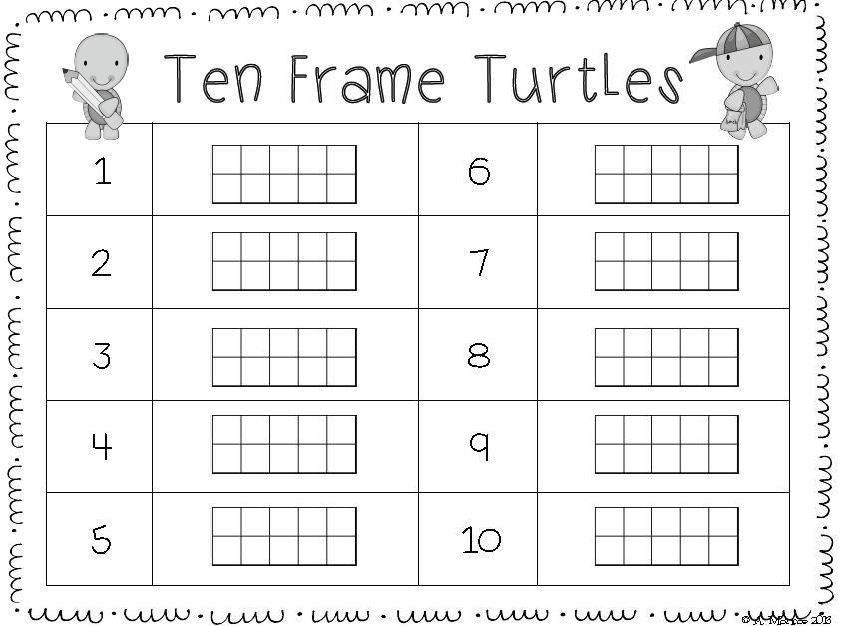
s

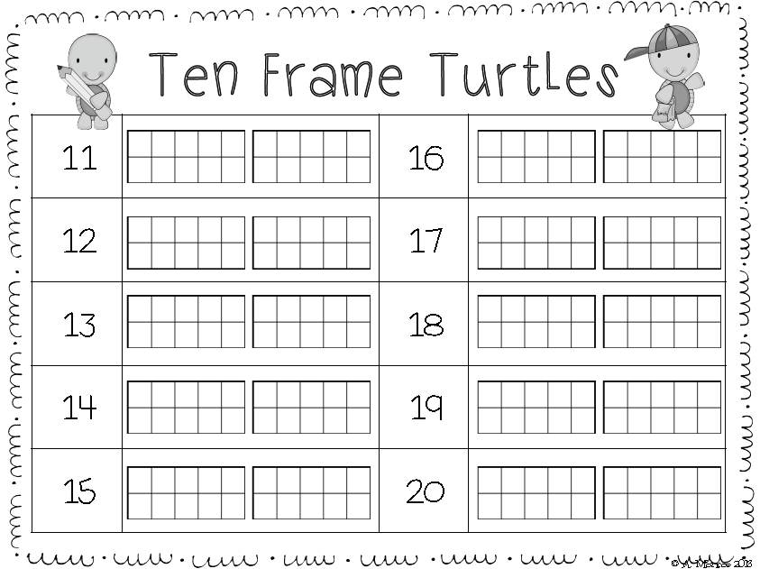
s

