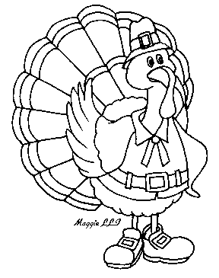

NOVEMBER

FAMILY HOMEWORK PROJECT

Dear Families,

This Tom Turkey does not want to be eaten on Thanksgiving Day! Brainstorm together some fun ways to disguise him so the farmer can’t find him when it’s time for dinner. Be creative and use any materials you want. Then work together to write a few sentences about his disguise, and how he manages his escape! Some ideas include a snowman, a penguin, a princess, or a clown.

 Please return your completed project by Friday, November 14th. As with all our family projects, the students will each take a turn sharing their project with the class. Then these will be displayed in the hallway for everyone to enjoy. Be sure to title your writing, for example: “The Henle Family’s Princess Turkey.”

The week of November 10th will be a short week due to Veteran’s Day. Therefore, this project will take place of your child’s regular homework for the week of the 10th.I am sending it home early in case you need the weekend to work on it and or time to gather materials.

Have Fun!

Mrs. Henle



